2015 Lady Cardinal Basketball Camp
Doniphan-Trumbull High School Gym
June 15-18, 2015

Girls Entering GRADES 8-12 1:30- 3:30pm

Girls Entering GRADES 4-7 10:45am-12:30pm

Girls Entering GRADES 1-3 9:00-10:30am

Camp Staff: Girls attending the Lady Cardinal Skill Builder Camp will work with the girls High School coaches as well as former and current Lady Cardinal basketball players

Camp Purpose: At the Lady Cardinal basketball camp we will develop fundamental skills appropriate for each grade level. We want to begin to develop the skills that future Cardinals need to be successful. We also want to make the camp fun for all so we will compete in skill based competition using the fundamentals we learn each day! There will be adjustable basketball rims for younger ages so proper form can be taught!

What to Bring: Campers should come dressed for an active day of basketball. Please wear athletic shoes with clean soles to enhance their playing ability and to save the gym floor. Water bottles are also recommended.

Camp Cost & Registration: Players may pre‐register with the application below, but walk‐in’s the day of camp are welcome. Cost of all camps is $30 per player. Pre-Registration is required to receive a camp t-shirt! All checks payable to: Cardinal Girls Basketball . Pre-Registration needs to be completed by May 31!!

I hope to see all future Lady Cardinal Basketball players at the camp this year! Go Cardinals!

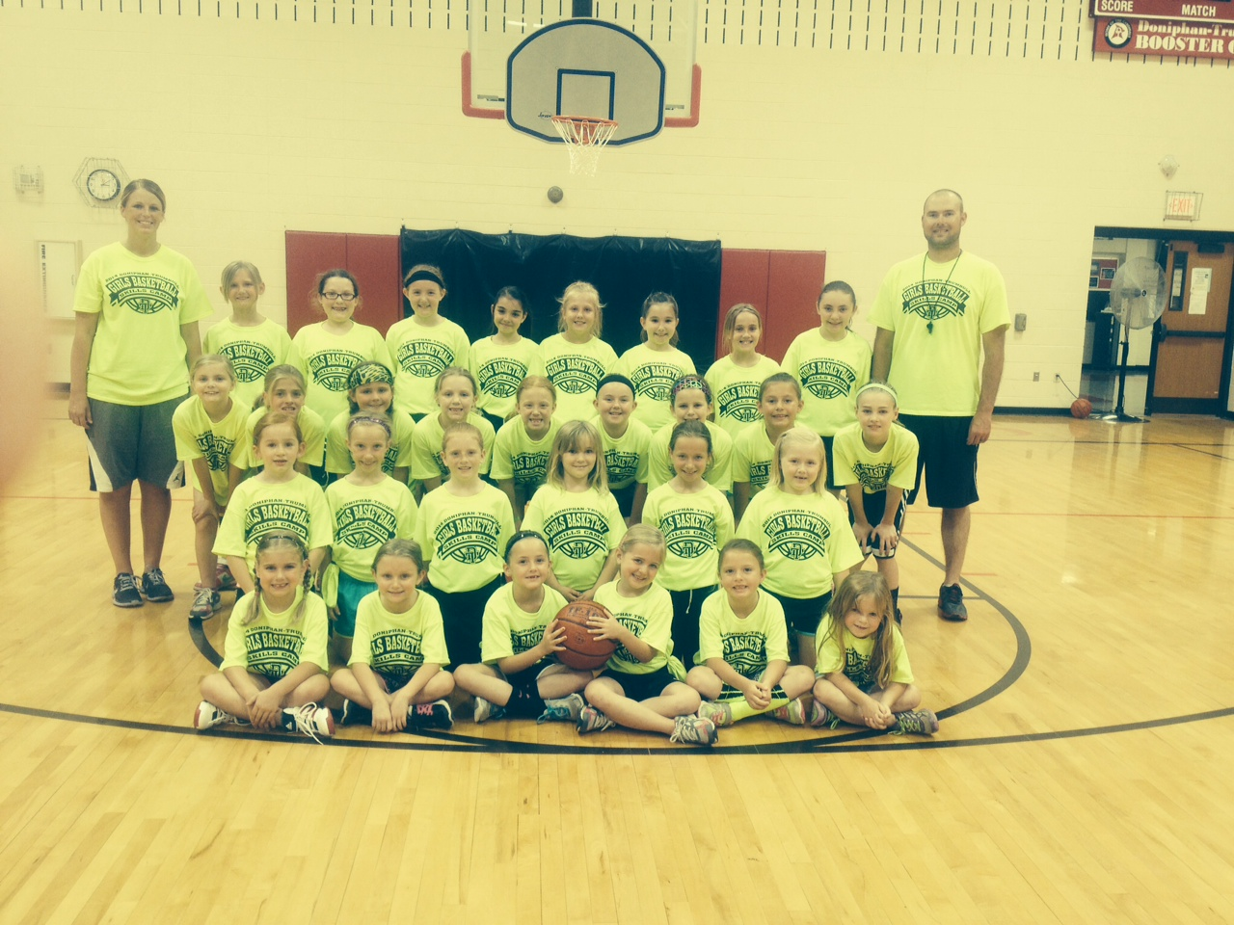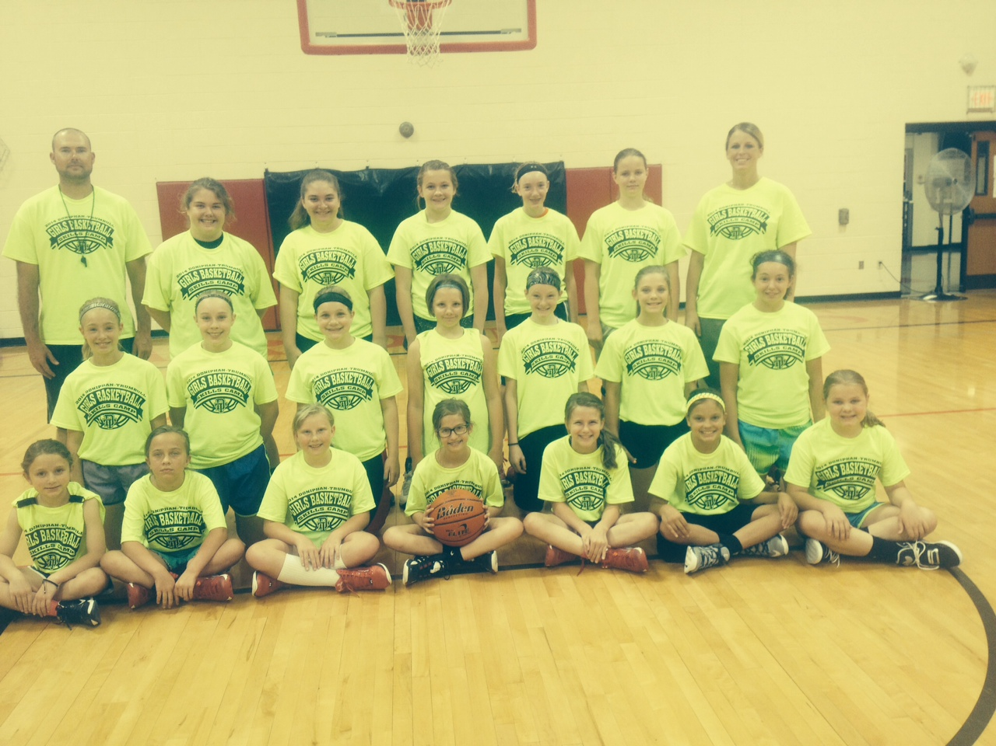

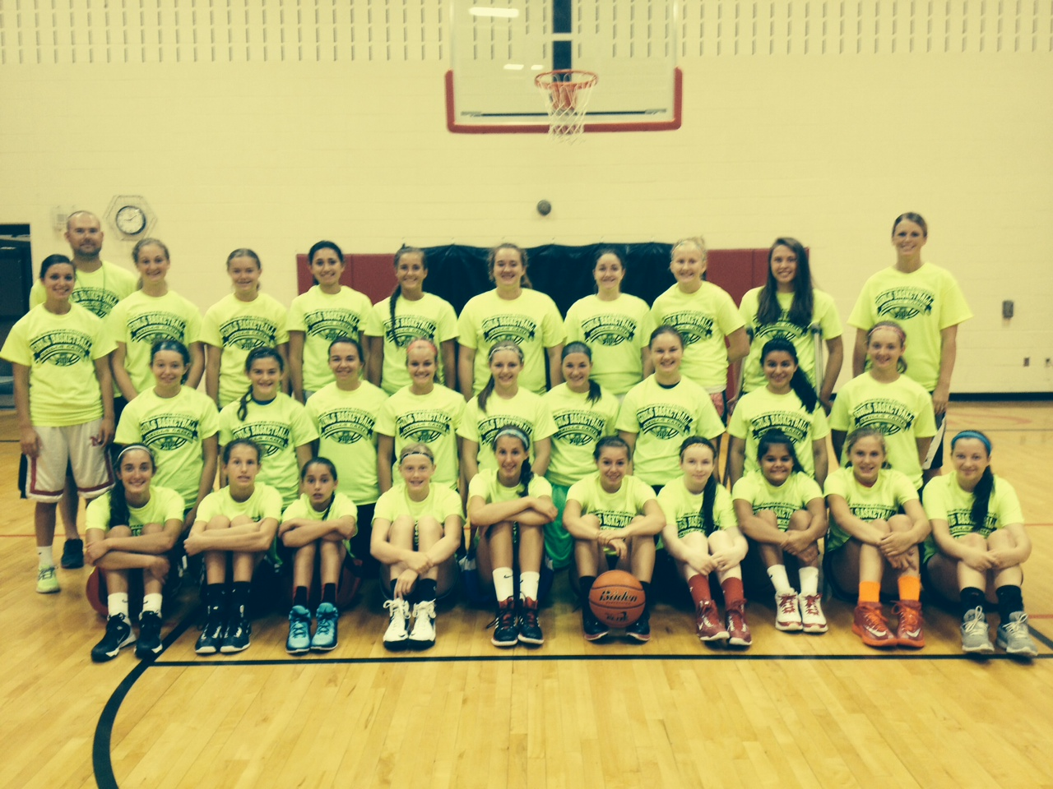

Questions? Contact Coach Davis: mdavis@dtcardinals.org
****************************************************************************************************
2015 Cardinal Lady Basketball Camp
Player Name ______________________________________________________________ Grade/Fall 2015_______________
Parent/Guardian’s Name _____________________________________________________________________________________
Address ______________________________________________________________
Home/Primary Phone # ___________________
Emergency Phone # _______________________________
Parent/Guardian E‐mail address ___________________________
T-Shirt Size ______________ (Sizes – Adult S, M, L, XL, XXL or Youth S,M,L)
Liability Release
I hereby give permission for my daughter to participate in the Cardinal Basketball Camp. I also agree that neither the school nor the representatives will be held responsible for any injury to the named student in the course of such activity. I understand that Doniphan‐Trumbull Public School District does not provide insurance for students participating in the summer camps and that it is the responsibility of the Parent/Guardian.

Parent/Guardian Signature ___________________________________________________ Date ______________________

Mail to: Cardinal Girls Basketball
Doniphan-Trumbull High School
Doniphan, NE 68832

