2014 DT Lady Cardinals Basketball Camp
Doniphan-Trumbull High School Gym
June 2-6, 2014

Girls Entering Grades 9-12 Monday -Friday– 9am-12pm
Girls Entering 8th Grade Monday & Tuesday – 9am-12pm-Wednesday-Friday 1:00-2:30
Girls Entering Grades 5-7 Monday 1:00-4:00 – Tuesday-Friday 1:00-2:30
Girls Entering Grades 1-4 Monday 1:00-4:00 – Tuesday-Friday 3:00-4:15
*PLEASE NOTE DAY AND TIMES AS THEY VARY*

Camp Staff: This year we are happy to announce that along with the Lady Cardinal Basketball staff and former players, we will also be welcoming Coach Jeff Thober to come in and share his basketball knowledge. Coach Thober has been a highly successful coach at Ravenna for many years and has the following credentials;
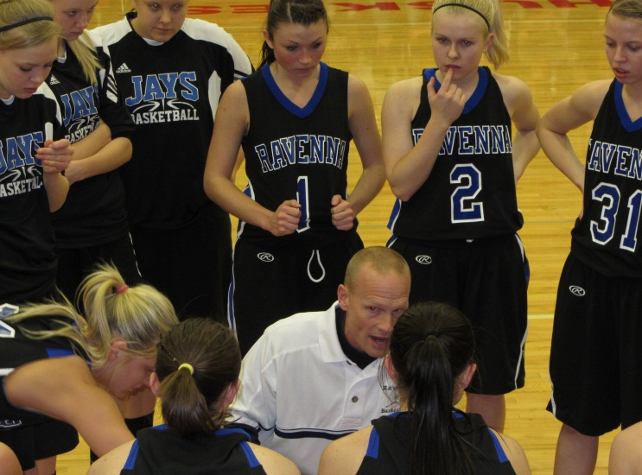
ACCOMPLISHMENTS
- Head Coach Nebraska Coaches Association All Star Team (2012)
- State Champion (2009) undefeated season 27-0
- State Champion (2006)
- State Champion Runner-Up (2004)
- Overall record of 218 wins & 83 losses
- 3 district championships / 5 sub district championships
- 5 Lou Platte conference championships
> (2005, 2006, 2008, 2009, 2011)
- Grand Island Independent Coach of the Year
> 2006

Coach Thober and the rest of the coaching staff will work with the girls on fundamental skills including ball handling, shooting, transition offense, screening, finishing at the basket and other skills! Coach Thober will be working with the younger age group on Monday and the older group Monday and Tuesday.

Camp Purpose: At the Lady Cardinal basketball camp we will develop fundamental skills appropriate for each grade level. We want to begin to develop the skills that future Cardinals need to be successful. We also want to make the camp fun for all so we will compete in skill based competition using the fundamentals we learn each day!

What to Bring: Campers should come dressed for an active day of basketball. Please wear athletic shoes with clean soles to enhance their playing ability and to save the gym floor. Water bottles are also recommended.

Camp Cost & Registration: Players may pre‐register with the application below, but walk‐in’s the day of camp are welcome. Cost of all camps is $40 per player. Pre-Registration is required to receive a camp t-shirt! All checks payable to: Cardinal Girls Basketball . Pre-Registration needs to be completed by May 31!!

Questions? Contact Coach Davis: mdavis@dtcardinals.org

2014 Cardinal Lady Basketball Camp
Player Name ______________________________________________________________ Grade/Fall 2014_______________
Parent/Guardian’s Name _____________________________________________________________________________________
Address ______________________________________________________________
Home/Primary Phone # ___________________
Emergency Phone # _______________________________
Parent/Guardian E‐mail address ___________________________
T-Shirt Size ______________ (Sizes – Adult S, M, L, XL, XXL or Youth S,M,L)
Liability Release
I hereby give permission for my daughter to participate in the Cardinal Basketball Camp. I also agree that neither the school nor the representatives will be held responsible for any injury to the named student in the course of such activity. I understand that Doniphan‐Trumbull Public School District does not provide insurance for students participating in the summer camps and that it is the responsibility of the Parent/Guardian.

Parent/Guardian Signature ___________________________________________________ Date ______________________
Mail to: Cardinal Girls Basketball
Doniphan-Trumbull High School
PO Box 300
Doniphan, NE 68832

